

**“AZƏRBAYCAN HAVA YOLLARI” CJSC**

**NATIONAL AVIATION ACADEMY**

**Topic**: Cloud storages

**Subject**: Operating Systems

**Teacher**: Mammad Sahmaliyev

**Group**: 2450i

**Student**: Alakbarova Rahimakhanim

**Date**: 31.10.22

**Signature**: Alakbarova Rahimakhanim

**Baku 2022**

**Cloud storage is a data deposit model in which digital information such as documents, photos, videos and other forms of media are stored on virtual or cloud servers hosted by third parties. It allows you to transfer data on an offsite storage system and access them whenever needed.**

Cloud storage is a [cloud computing](https://www.spiceworks.com/tech/cloud/articles/what-is-cloud-computing/) model that allows users to save important data or media files on remote, third-party servers. Users can access these servers at any time over the internet. Also known as utility storage, cloud storage is maintained and operated by a cloud-based service provider.

From greater accessibility to data backup, cloud storage offers a host of benefits. The most notable being large storage capacity and minimal costs. Cloud storage delivers on-demand and eliminates the need to purchase and manage your own data storage infrastructure. With “anytime, anywhere” data access, this gives you agility, global scale and durability.

**How Cloud Storage Works**

Cloud storage works as a virtual data center. It offers end users and applications [virtual storage infrastructure](https://www.spiceworks.com/tech/cloud/tech-101/virtualization-in-cloud-computing-hardware-software-desktop-data-more/) that can be scaled to the application’s requirements. It generally operates via a web-based API implemented remotely through its interaction with in-house cloud storage infrastructure.

Cloud storage includes at least one data server to which a user can connect via the internet. The user sends files to the data server, which forwards the message to multiple servers, manually or in an automated manner, over the internet. The stored data can then be accessed via a web-based interface.

To ensure the constant availability of data, cloud storage systems involve large numbers of data servers. Therefore, if a server requires maintenance or fails, the user can be assured that the data has been moved elsewhere to ensure availability.

**Types of Cloud Storage**

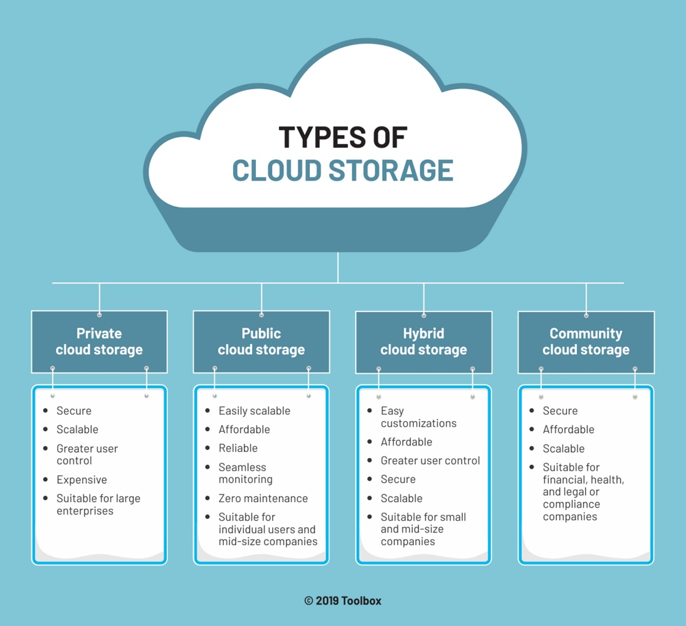

Cloud services have made it possible for anyone to store digital data and access it from anywhere. This means that cloud storage is essentially a virtual hard drive. From saving important data such as word documents, and video files, to accessing the cloud to process complex data and run applications – cloud storage is a versatile system.

### 1. Private cloud storage

Private cloud storage is also known as enterprise or internal cloud storage. Data is stored on the company or organization’s intranet in this case. This data is protected by the company’s own firewall. Private cloud storage is a great option for companies with expensive data centers and can manage data privacy in-house. A major advantage of saving data on a private cloud is that it offers complete control to the user. On the other hand, one of the major drawbacks of private cloud storage is the cost and effort of maintenance and updates. The responsibility of managing private cloud storage lies with the host company.

### 2. Public cloud storage

Public cloud storage requires few administrative controls and can be accessed online by the user and anyone else who the user authorizes. With public cloud storage, the user/company doesn’t need to maintain the system. Public cloud storage is hosted by different solution providers, so there’s very little opportunity for customizing the security fields, as they are common for all users. Amazon Web Services (AWS), IBM Cloud, Google Cloud, and Microsoft Azure are a few popular public cloud storage solution providers. Public cloud storage is easily scalable, affordable, reliable and offers seamless monitoring and zero maintenance.

### 3. Hybrid cloud storage

Hybrid cloud storage is a combination of private and public cloud storage. As the name suggests, hybrid cloud storage offers the best of both worlds to the user – the security of a private cloud and the personalization of a public cloud. In a hybrid cloud, data can be stored on the private cloud, and information processing tasks can be assigned to the public cloud as well, with the help of cloud computing services. Hybrid cloud storage is affordable and offers easy customization and greater user control.

### 4. Community cloud storage

Community cloud storage is a variation of the private cloud storage model, which offers cloud solutions for specific businesses or communities. In this model, cloud storage providers offer their cloud architecture, software and other development tools to meet the community’s requirements. Any data is stored on the community-owned private cloud storage to manage the community’s security and compliance needs. Community cloud storage is a great option for health, financial or legal companies with strict compliance policies.

### Benefits of cloud storage

* + **Flexibility and ease of access**: Cloud storage means that your data is not tied down to any one location. Various stakeholders can access assets stored on the cloud from a location and device of their choice without any download or installation hassles.
  + **Remote management support**: Cloud storage also paves the way for remote management either by internal IT teams or by managed service providers (MSPs). They can troubleshoot without being present on-site, speeding up issue resolution.
  + **Fast scalability**: A major benefit of cloud storage is that you can provision new resources with only a few clicks without the need for any additional infrastructure. When faced with an unprecedented increase in data volumes, this feature aids business continuity.
  + **Redundancy for backup**: Data redundancy (i.e., replicating the same data in multiple locations) is essential for an effective backup mechanism. The cloud ensures your data is kept secure in a remote location in case of a natural disaster, accident, or cyberattack.
  + **Long-term cost savings**: In the long-term, cloud storage can save you significantly in the costs of hardware equipment, storage facilities, power supply, and personnel, which are sure to multiply as your organization grows.